**USING TEAMS: Now that you logged into teams here are some important things to know.**

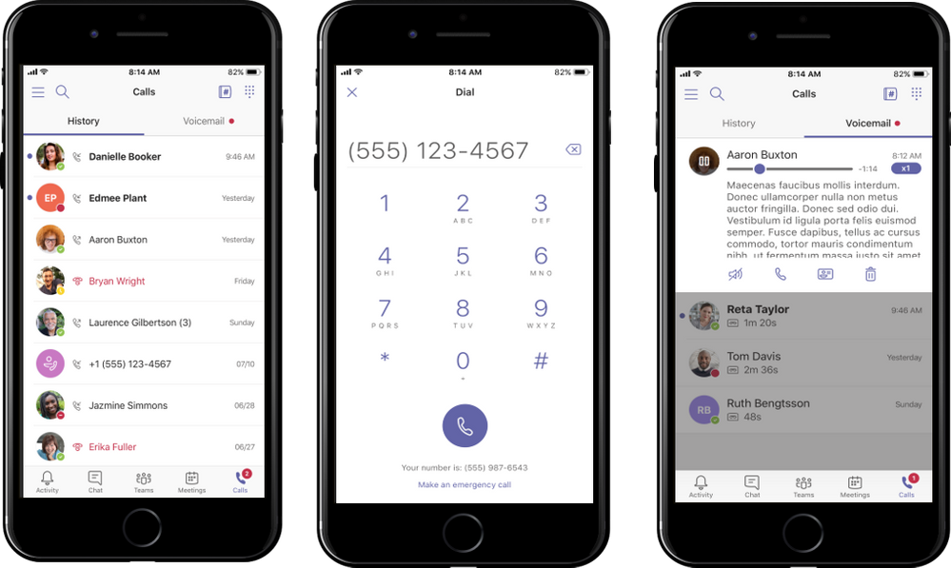**This is what the side of your teams page looks on a computer.**

**🡨 🡨 🡨**

**^^This is what it looks like on the bottom of the mobile app. ^^**

**How to Access and Complete Assignments**

1. Select the name of your class from the Teams Dashboard.

2. Click **Assignments** at the top of the screen 

🡨🡨 or the menu on the left.

3. Select the assignment.

4. Follow your teacher instructions shown for the assignment. If applicable, click the Add Work link to submit a file or link to your teacher.Many students have forgotten this on some past assignments.

5. Click the blue **Turn in** button at the top right corner when you finish.

**How to Access Files Posted by Teacher**

1. Select the name of your class from the Teams Dashboard.

2. Click **Files** at the top of the screen.



Access, edit and complete work in files.

**How to use Class Notebook**



1. Select your teacher and their teams page. **Make sure you are on the General page,** not another channel. Select Class Notebook from the top menu on a computer
2. You will see the first image on the left when you click Class Notebook.
3. Click the Small (>) symbol to open up the menu you see below on the right.
4. 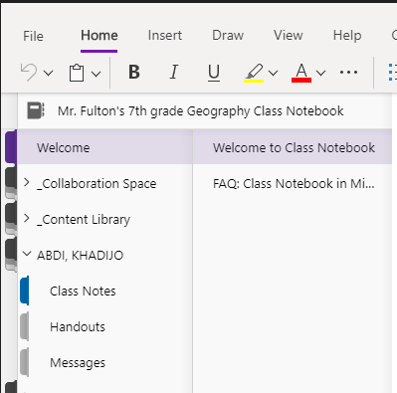Find and click on your name to use your Class Notebook. Each tab under your name, is a different work page

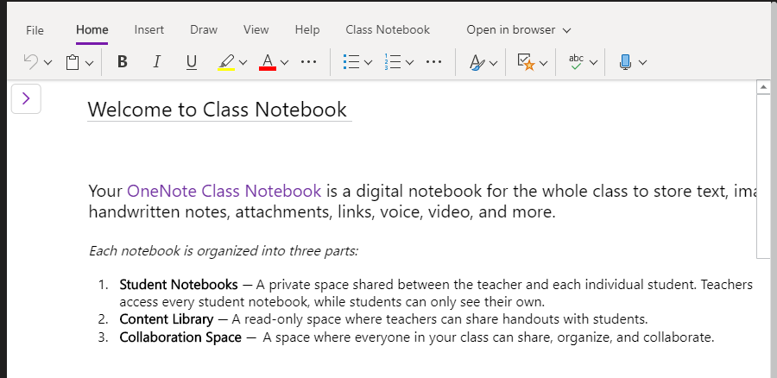

**On the mobile app for phones or iPad,** start in the teams tab click “general” under your teachers team. . Then in the top right click “More” and you should see the Class Notebook to access it. (See below left image)

At the top of the general page there are 3 tabs: Posts, Files, More. Please click “More” (See below middle image)

Class Notebook will be an option after clicking the “more” tab. (see below right image)

This will take you to another app that may need to be downloaded “One Notebook”. Use the same process you did to download the teams app.

